# Ideation Phase

**Define the Problem Statements**

|  |  |
| --- | --- |
| Date | 27 September 2022 |
| Team ID | PNT2022TMID51225 |
| Project Name | Signs with smart connectivity for better road  safety |
| Maximum Marks | 2 Marks |

Activity Reference:

https://miro.com/welcomeonboard/TzVFUWJGM05Zam1BaDk1VUxiTktid0c3RGV0cXZzRk43 bm1uU28zTkRIa2ZYUWYwSmlua3IyT01GVFVrNmZXa3wzNDU4NzY0NTM0NDgzNzYwOTA2fD I=?share_link_id=273385705533

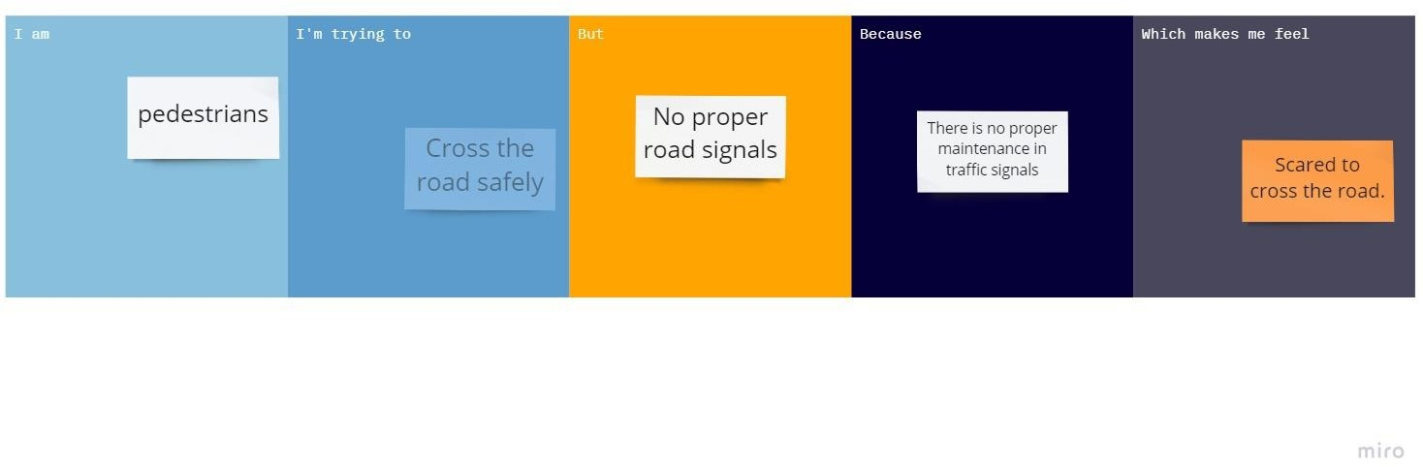

|  |  |  |  |  |  |
| --- | --- | --- | --- | --- | --- |
| **Problem Statement (PS)** | **I am (Customer)** | **I’m trying to** | **But** | **Because** | **Which makes me feel** |
| PS-1 | Traffic police | Direct the people in the traffic | cannot able to instruct the  people everytime | instruct them manually, If traffic signs didn’t work | To teach about the road safety |
| PS-2 | Vehicles | Reach my destination safely | There occurs many  accidents | People are not following the  traffic rules | Not to travel outside |